3.5 I can demonstrate a working development project and describe the main features

Looking back on this project has made have more knowledge on what is needed for a project and the following screenshots are of the final project working:



[The above image is of the homepage which shows the Header reading Software Development - Unit 33]

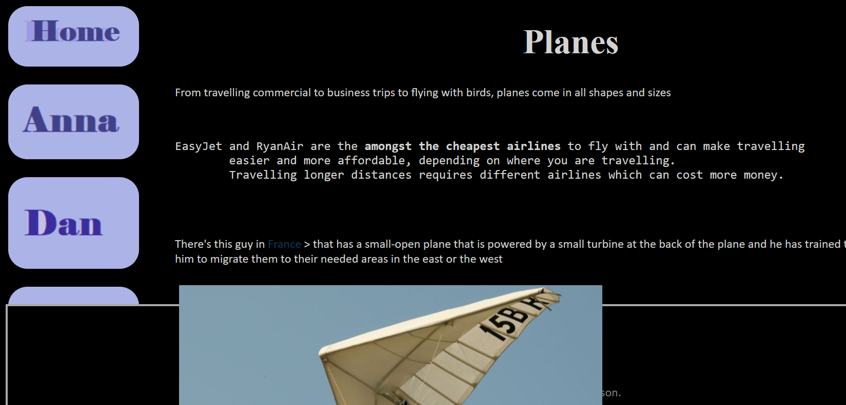

[The above image is of my web page that I created]

Although the footer isn’t where it should be, that is a CSS issue.

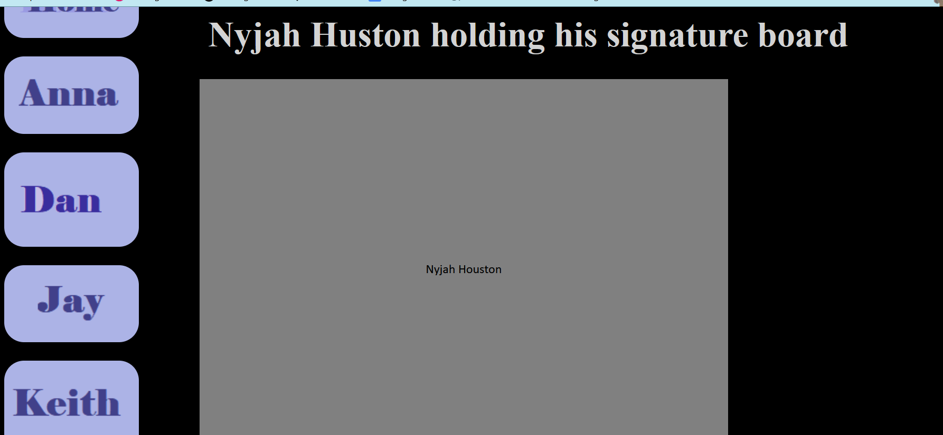

[The above image is of Paul’s page]

This shows the CSS working with the overlay ALT text that we implemented into the site.

All the navigation buttons on the side go to their allocated web pages and the footer has our names and the title for the project.



[The above image shows the Footer for the website]

During our time creating this project we used an Agile method to keep everything up to date and had discussions on MS teams and a Trello board.